Day-5

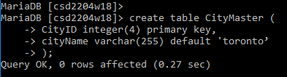

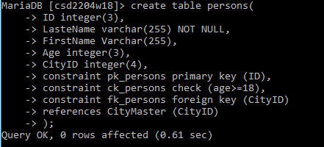

* insert into citymaster(CityID) values(2);

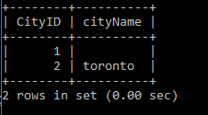

* insert into persons values(1,'Muliyana','Jaydeep',22,2);

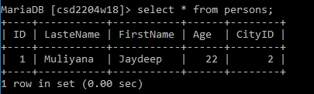

* show index from CityMaster;

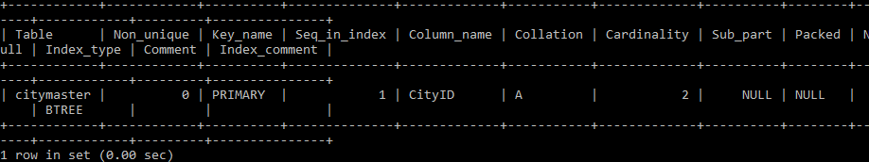

* show index from persons;

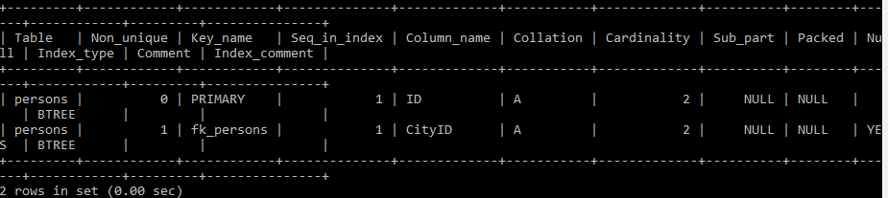

* create table a1 AS select \* from CityMaster;

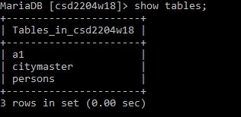

* create table a2 AS select \* from persons;

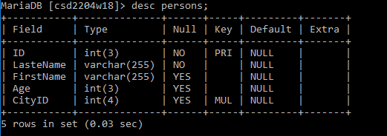

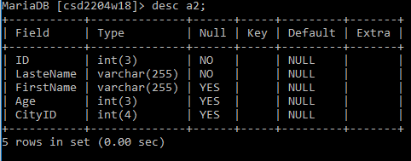

* create table a3 LIKE persons;

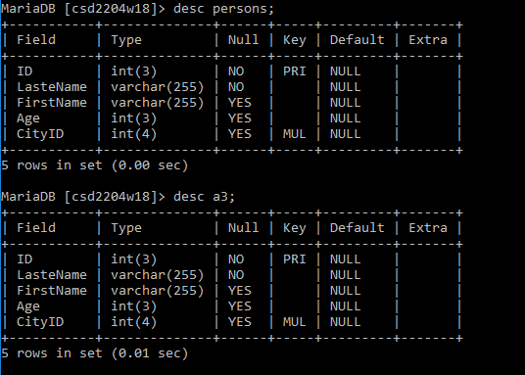

* insert into a3 select \* from persons;

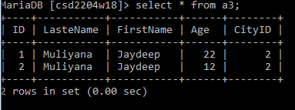

* insert into c3 select \* from c1 where city like 'New%';

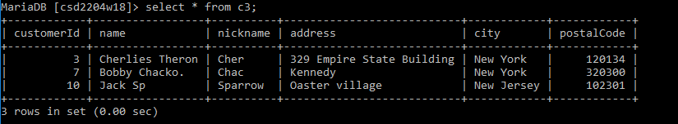

* insert into persons values (3,'Abc','Def',10,1);

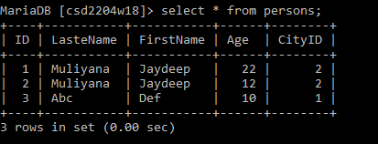

* select version();

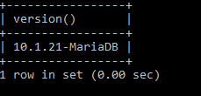

* select database();

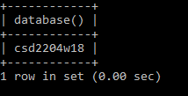

* alter table CityMaster add column country varchar(100);

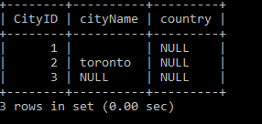

* alter table CityMaster modify column country varchar(20);

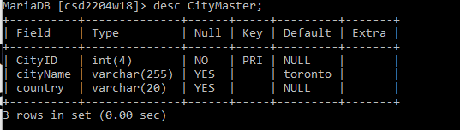

* alter table CityMaster change column country dist varchar(20);

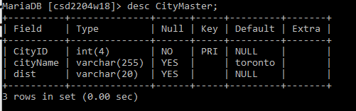

* alter table CityMaster drop column dist;

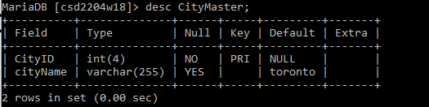

* alter table a1 add primary key (CityID);

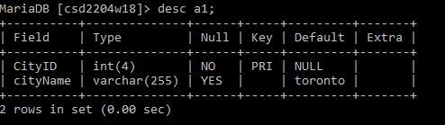

* alter table a1 add constraint unique (CityName);

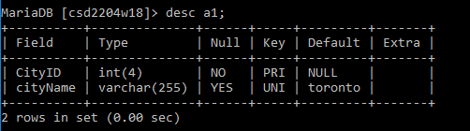

* alter table a1 modify cityName varchar(30) not NULL;

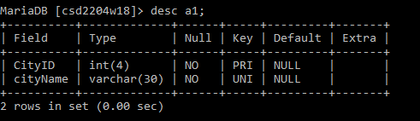

* alter table a1 drop index CityID;
* update CityMaster set CityName= 'Vancouver' where CityID=2;

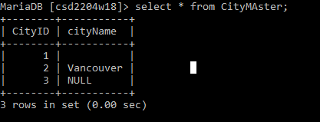

* update CityMaster set CityName='London';

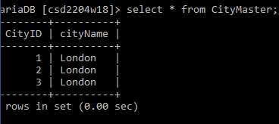

* delete from CityMaster where CityID=3;

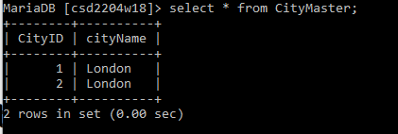

* drop table a1;

